Three Address Code:

Aim:
To generate Three Address Code (TAC) for a given arithmetic expression using stacks and operator precedence.

Algorithm:
- Read the input arithmetic expression and separate the target variable from the right-hand-side expression.
- Scan the expression from left to right and push operands into the operand stack and operators into the operator stack according to precedence.
- When an operator is processed, pop two operands, generate a temporary variable, and create a TAC instruction.
- Continue processing until all operators are handled, then assign the final temporary result to the target variable.

Pseudocode:
BEGIN

Read the arithmetic expression

Separate the target variable from the expression

Initialize operator stack and operand stack
Initialize temporary variable count

Scan the expression from left to right

IF the character is an operand
Push operand into operand stack

ELSE IF the character is '('
Push it into operator stack

ELSE IF the character is ')'
Process operators until '(' is found
Remove '(' from operator stack

ELSE IF the character is an operator
While the top operator has higher or equal precedence
Pop the operator
Pop two operands
Create a temporary variable
Generate TAC instruction
Push temporary variable into operand stack
End While

Push current operator into operator stack

END IF

Process all remaining operators

Pop the final result from operand stack

Assign the final result to the target variable

Display the Three Address Code

END

Code:
#include <stdio.h>
#include <stdlib.h>
#include <ctype.h>
#include <string.h>
#define MAX 100
// Stack structures for operators and operands
char opStack[MAX];
int opTop = -1;
char* valStack[MAX];
int valTop = -1;
int tempCount = 1;
void pushOp(char ch) {
if (opTop < MAX - 1) {
opStack[++opTop] = ch;
}
}
char popOp() {
if (opTop >= 0) {
return opStack[opTop--];
}
return '\0';
} char peekOp() {
if (opTop >= 0) {
return opStack[opTop];
}
return '\0';
}
void pushVal(char* val) {
if (valTop < MAX - 1) {
valStack[++valTop] = strdup(val);
}
}
char* popVal() {
if (valTop >= 0) {
return valStack[valTop--];
}
return NULL;
}
// Define operator precedence
int precedence(char op) {
if (op == '+' || op == '-') return 1;
if (op == '*' || op == '/') return 2;
return 0;
}
// Generates TAC instruction and pushes the temporary variable onto
the operand stack
void processOperator() {
char op = popOp();
char* right = popVal();
char* left = popVal(); char* temp = (char*)malloc(10 * sizeof(char));
sprintf(temp, "t%d", tempCount++);
printf("%s = %s %c %s\n", temp, left, op, right);
pushVal(temp);
free(left);
free(right);
}
void generateTAC(char* expr) {
int i = 0;
// Separate target variable (e.g., "a") from the RHS expression
char target[MAX] = "";
int targetIdx = 0;
while (expr[i] != '=' && expr[i] != '\0') {
if (!isspace(expr[i])) {
target[targetIdx++] = expr[i];
}
i++;
}
target[targetIdx] = '\0';
if (expr[i] == '=') {
i++; // Skip '='
} else {
// If no '=', treat entire input as expression
i = 0;
target[0] = '\0'; }
printf("\nThree Address Code (TAC):\n");
printf("-------------------------\n");
// Process the RHS using Dijkstra's Shunting-Yard algorithm
variant
while (expr[i] != '\0') {
if (isspace(expr[i])) {
i++;
continue;
}
// Parse variable or constant identifier
if (isalnum(expr[i])) {
char operand[MAX];
int k = 0;
while (isalnum(expr[i])) {
operand[k++] = expr[i++];
}
operand[k] = '\0';
pushVal(operand);
}
else if (expr[i] == '(') {
pushOp(expr[i]);
i++;
}
else if (expr[i] == ')') {
while (opTop >= 0 && peekOp() != '(') {
processOperator();
}
popOp(); // Pop '('
i++; }
else if (expr[i] == '+' || expr[i] == '-' || expr[i] == '*' || expr[i] ==
'/') {
while (opTop >= 0 && precedence(peekOp()) >=
precedence(expr[i])) {
processOperator();
}
pushOp(expr[i]);
i++;
}
else {
i++;
}
}
// Process remaining operators on stack
while (opTop >= 0) {
processOperator();
}
// Assign final result to the target variable
char* finalRes = popVal();
if (target[0] != '\0' && finalRes != NULL) {
printf("%s = %s\n", target, finalRes);
}
if (finalRes) free(finalRes);
}
int main() {
char expr[MAX] = "a = b * c + d";
printf("Input Expression: %s\n", expr); generateTAC(expr);
return 0;
}

Ouput:
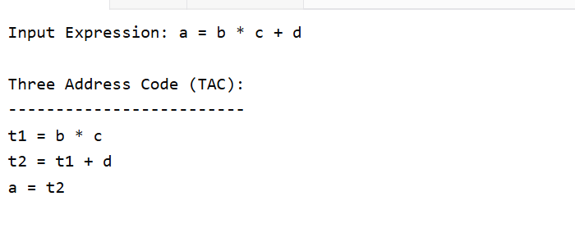

Result:
Thus, the given arithmetic expression was successfully converted into Three Address Code (TAC) using operator and operand stacks.

